Section 1: Case Summary

Scenario Title: | COVID-19: Out of Hospital Cardiac Arrest
Keywords: | COVID-19, cardiac arrest, EHS, resuscitation
Brief Description of Case: | The patient is found by a friend unresponsive after a 7 day history of cough and shortness of breath. He immediately receives bystander CPR. An advanced care paramedic crew attends the scene and manages a ventricular fibrillation arrest prior to transporting to hospital. The patient goes into cardiac arrest again shortly before arriving in the emergency department. The team will need to prepare for the patient's arrival and then manage a cardiac arrest using appropriate precautions for suspected COVID-19.

Goals and Objectives
Educational Goal: | Safely and successfully manage an out of hospital cardiac arrest in the patient where COVID-19 is suspected or cannot be ruled out.
Objectives:  (Medical and CRM) | - Appropriate don and doff airborne PPE in the patient where COVID-19 cannot be ruled out and an aerosol generating medical procedure is performed.  - Manage cardiac arrest in the patient where COVID-19 cannot be ruled out.  - Demonstrate effective crisis resource management including role assignment and closed loop communication.
EPAs Assessed: | N/A

Learners, Setting and Personnel
Target Learners: | ☐ Junior Learners |  | ☐ Senior Learners |  |  | ☒ Staff
 | ☒ Physicians | ☒ Nurses |  | ☒ RTs | ☒ Inter-professional
 | ☐ Other Learners:
Location: | ☐ Sim Lab |  | ☒ In Situ |  |  | ☐ Other:
Recommended Number of Facilitators: | Instructors: 1
 | Confederates: 0
 | Sim Techs: 1

Scenario Development
Date of Development: | April 16, 2020
Scenario Developer(s): | Trevor Campbell, ACP and Dr. Jared Baylis
Affiliations/Institutions(s): | Kelowna General Hospital
Contact E-mail: | jbaylis@qmed.ca
Last Revision Date: | April 20, 2020
Revised By:
Version Number:

Section 2A: Initial Patient Information

- Patient Chart
Patient Name: Tom Philips |  |  |  | Age: 58 | Gender: Male | Weight: 90Kg
Presenting complaint: Post cardiac arrest
Temp: 38.4C | HR: 110 | BP: 80/60 |  | RR: 12 with BVM on iGel SGD | O₂Sat: 92% | FiO₂: 100%
Cap glucose: 6.2 |  |  |  | GCS: 3 (E1 V1 M1 )
Triage note: Patient being transported by advanced care paramedic crew, post VF arrest. Pt was found unresponsive by friend, immediate bystander CPR prior to EHS. EHS arrived and performed CPR. ROSC was obtained and the patient’s vitals afterwards were HR 110 sinus tachycardia, BP 80/60, no intrinsic respiratory effort, being ventilated with an iGel supraglottic device in place, GCS 3. ECG at the scene showed anterior ST elevation.
Allergies: Sulfa drugs
Past Medical History:  HTN  COPD  1 pack/day smoker  “Frequent Pneumonia” |  |  | Current Medications:  Ramipril 2.5mg PO BID  Salbutamol inhaler prn  Tiotropium bromide inhaler

Section 2B: Extra Patient Information

A. Further History
Following to be reported by paramedic (info gathered from bystander):

Patient awoke at 0800, complained of chest pain, SOB, and mild cough. He smoked some marijuana and went back to bed. At 1000 he got up, came into the living room and collapsed. Pt had been complaining of productive cough, fever, moderate SOB and lethargy for 7 days. It is unknown if patient had any contact with COVID-19 positive patients. The patient had not seen their family doctor, felt this was just a normal bought of pneumonia and was taking self-prescribed antibiotics left over from past treatments (clarithromycin).

The patient was treated with full ACLS modified for COVID-19 including 2 large bore IV’s, 1mg EPI Q3 mins x5 doses, 450 mg Amiodarone (300mg +150mg second dose), multiple defibrillations, and ventilated through an iGel supraglottic device. ROSC at 10:25, vitals absent again 2 minutes prior to arrival in the ED.

B. Physical Exam
List any pertinent positive and negative findings
Cardio: Cardiac arrest | Neuro: Unresponsive
Resp: Course crackles bilaterally with ventilation | Head & Neck: Nil
Abdo: Nil | MSK/skin: Nil
Other: Nil

Section 3: Technical Requirements/Room Vision

A. Patient
☒ Mannequin (specify type and whether infant/child/adult)
☐ Standardized Patient
☐ Task Trainer
☐ Hybrid
B. Special Equipment Required
Mock airborne PPE
Defibrillator
Intubation equipment

C. Required Medications
Epinephrine
Norepinephrine
STEMI meds (ASA, ticagrelor, heparin, etc)

D. Moulage
E. Monitors at Case Onset
☒ Patient on monitor with vitals displayed
☐ Patient not yet on monitor
F. Patient Reactions and Exam
Include any relevant physical exam findings that require mannequin programming or cues from patient
(e.g. – abnormal breath sounds, moaning when RUQ palpated, etc.) May be helpful to frame in ABCDE format.

Airway – actively being ventilated through iGel supraglottic device
Breathing – 100% FiO2 through SGD, bibasilar crackles
Circulation – periphery cool to touch and pulses thready

Section 4: Confederates and Standardized Patients

Confederate and Standardized Patient Roles and Scripts
Role | Description of role, expected behavior, and key moments to intervene/prompt learners. Include any script required (including conveying patient information if patient is unable)
None | None required. Use in situ personnel in their usual role as best possible.

Section 5: Scenario Progression

Scenario States, Modifiers and Triggers
Patient State/Vitals | Patient Status | Learner Actions, Modifiers & Triggers to Move to Next State |  | Facilitator Notes
1. Baseline State  Rhythm: VF  HR: 0  BP: 0  RR: 12 via BVM on SGD  O₂SAT: n/a  T: 38.4ºC  GCS: 3 | Is the patient alert? In distress? Seizing? What symptoms do they currently have? | Expected Learner Actions  Safely don airborne PPE  Take handover from EHS  Continue ACLS management  Continue chest compressions with ventilations every 6 seconds  Apply defibrillator pads and conduct rhythm check, shock  Notify cath lab of patient with prehospital STEMI now in cardiac arrest with suspected COVID-19 | Modifiers  Changes to patient condition based on learner action  Triggers  For progression to next state  - Shock x1 2. ROSC
2. ROSC  Rhythm: Sinus tachy  HR: 110  BP: 80/60  RR: 12 via BVM on SGD  O₂SAT: 92%  T: 38.4ºC  GCS: 3 |  | Expected Learner Actions  Full set of vitals, ECG, labs, COVID-19 swab, consider XR  Start vasoactive infusion  Liaise with cardiology/cath lab now that ROSC achieved with repeat ECG showing STEMI  Secure definitive airway  Consult ICU | Modifiers  Norepinephrine infusion BP increased to 95/75  Triggers  - All actions complete or 5-6 mins 3. Transfer & handover
3. Transfer & Handover  VS unchanged |  | Expected Learner Actions  Handover to cath lab team  Patient transported to cath lab with airborne precautions  Update patient’s family | Modifiers  Triggers  - Actions complete 4. Doff PPE
4. Doff PPE |  | Expected Learner Actions  Have trained observer guide through PPE doffing of entire team | End Case

Appendix A: Laboratory Results

No blood work given during case

Appendix B: ECGs, X-rays, Ultrasounds and Pictures

Paste in any auxiliary files required for running the session. Don’t forget to include their source so you can find them later!

Prehospital ECG (Source: https://commons.wikimedia.org/wiki/File:12_lead_generated_anterior_MI.JPG)
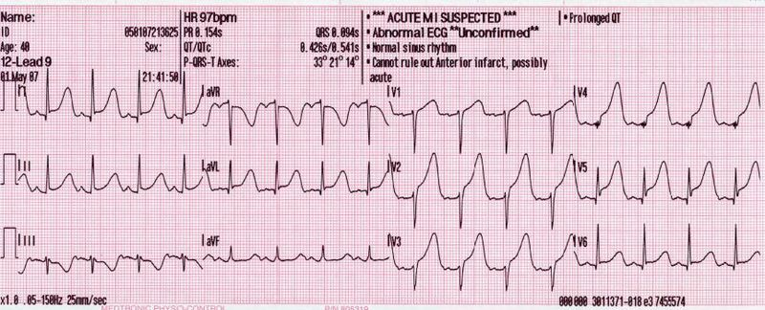

ED ECG Post ROSC (Source: https://en.wikipedia.org/wiki/File:12_Lead_EKG_ST_Elevation_tracing_only.jpg)
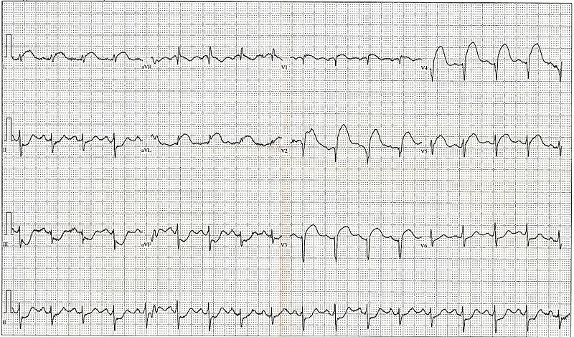

Appendix C: Facilitator Cheat Sheet & Debriefing Tips

Include key errors to watch for and common challenges with the case. List issues expected to be part of the debriefing discussion. Supplemental information regarding any relevant pathophysiology, guidelines, or management information that may be reviewed during debriefing should be provided for facilitators to have as a reference.

This case was designed to simulate the pathway of a patient going from pre-hospital through to ED with suspicion of COVID-19 and ongoing aerosol generating medical procedure needs.

There are multiple guidelines out there depending on your institution and location. We have intentionally not included any specific guidelines for PPE or for managing cardiac arrest in the suspected COVID-19 patient (aside from the broad AHA guidelines) so that you can build your own institutional guidelines into your simulation and debrief.

Here are some suggested debrief points to discuss:

- What PPE should prehospital providers be wearing in the field when dealing with aerosol generating medical procedures?
- How best should cardiac arrest and airway compromise be managed in the field?
- On arrival to the ED with active CPR, where should the transition of care and handover occur when COVID-19 is suspected? In the ambulance bay, in the resuscitation bay, after ROSC?
- Who needs to be in the room during the management of cardiac arrest? Are there any ways to minimize personnel and therefore minimize exposure?
- What are some of the major differences between traditional ACLS and ACLS in the suspected COVID-19 patient?
- What are your institutional guidelines with regard to suspected COVID-19 patients being transferred to the cath lab or OR etc?
- What are some of the challenges with communication with full airborne PPE? Are there any ways around this?
- Is there a role for a mechanical compression device in this situation?
- What if you are in a community setting without a cath lab? What are the implications for transport or thrombolytics?
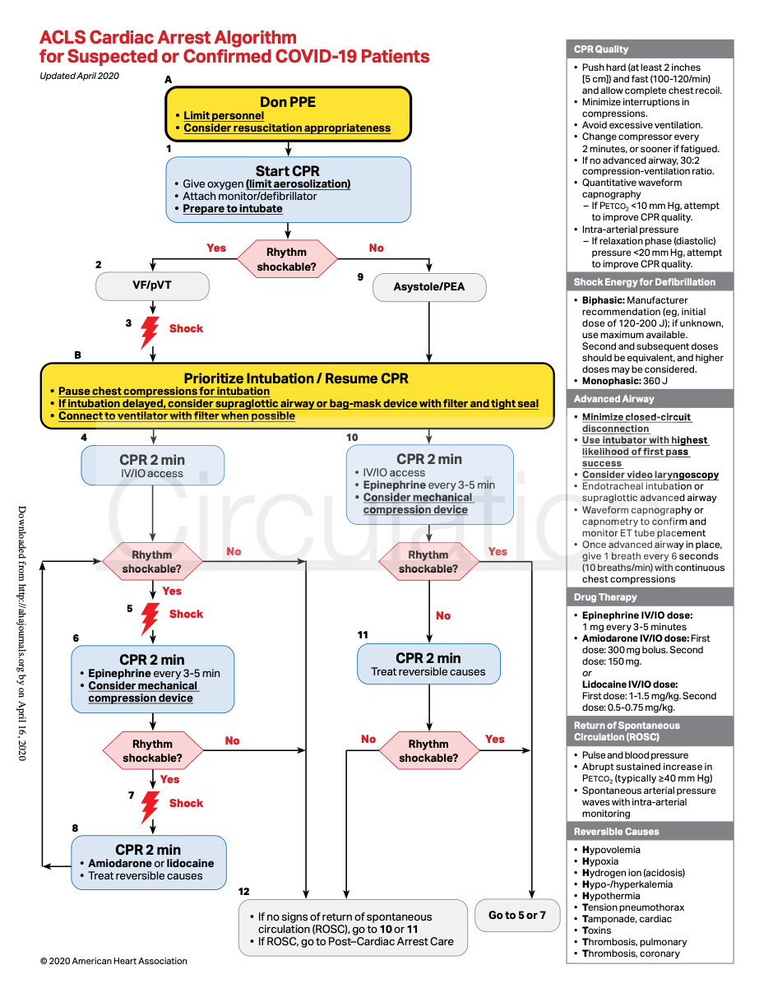

Source: https://www.ahajournals.org/doi/pdf/10.1161/CIRCULATIONAHA.120.047463

